BED 106 — BUSINESS ANALYTICS
Mini Business Analytics Capstone Project
Checkpoint 1: Data Fundamentals & SQL Querying
Preliminary Period — Weeks 1–4
Project Title: RetailPulse — Poblacion Grocery Mart
Business Domain: Retail & Sales Analytics
Group: Arowana Kings

Group Members and Roles:
Member Name | Role | Component
Angel Frederick Paredes | Lead Developer / Project Lead | Problem definition & KPI design, data cleaning/transformation/loading, SQL query design & database schema, dashboard design, testing & documentation
Jeeruz Marl Tabar | Research Support | Compiled candidate datasets and reference sources; reviewed data definitions
Luke Kibry Jao | Testing Support | Manual testing of dashboard queries and outputs across sample scenarios
Clein Lord Will Surigao | Documentation Review | Reviewed checkpoint write-ups and the final report

Instructor: Jessie A. Melendres
Talibon Polytechnic College
A.Y. 2026–2027 | 1st Semester

Task 1.1 — Business Problem Statement

Business Domain and Problem
Domain: Retail & Sales Analytics.
Business context: A grocery/supermarket-style retail store ("Poblacion Grocery Mart") operating in Poblacion, Talibon, Bohol — the commercial center of northern Bohol.
Problem: Grocery stores carry dozens of products across many categories, but without structured sales analysis, owners often cannot tell which categories actually drive revenue versus which merely occupy shelf space. Restocking, promotion, and pricing decisions end up based on intuition rather than data.

Why This Problem Matters
For a small neighborhood store like Poblacion Grocery Mart, margins are thin and shelf space is limited, so every peso tied up in slow-moving stock is a missed opportunity to stock something that actually sells. Without a clear picture of which categories and products drive revenue, the owner is left restocking, pricing, and promoting based on gut feel rather than what the transaction data actually shows. Turning raw sales records into clear insights can directly inform restocking schedules and pricing decisions, and can even highlight which products to feature during high-traffic days such as paydays — ultimately protecting the store’s cash flow and profitability. This approach is also not unique to one store; it reflects a data-driven decision-making process that other small retailers in Talibon and similar communities could apply to their own operations.

Key Business Questions
1. Which product categories generate the most revenue for the store?
2. Are high-revenue categories driven by high prices, high sales volume, or both?
3. How does revenue behave across the 6-month period — are there noticeable peaks (e.g., payday, holidays)?

Data Type and Source
A localized dataset, modeled on the structure and conventions of the Supermart Grocery Sales – Retail Analytics Dataset (Kaggle, 2022), built to represent 6 months of transaction data (January–June 2026) for a grocery store, structured as four relational tables (categories, products, transactions, transaction_items), totaling 9 categories, 40 products, 2,532 transactions, and 10,087 line items.

Task 1.2 — Dataset Documentation (Data Source Report)

Dataset Overview
Field | Value
Dataset name | Poblacion Grocery Mart Sales Dataset
Source | Structured following the Supermart Grocery Sales – Retail Analytics Dataset (Kaggle, 2022); localized for this project (see note below)
Date accessed/generated | August 22, 2026
License | Reference dataset (Kaggle) is CC0/Public Domain; localized data has no external license
Period covered | January 1, 2026 – June 30, 2026
Row counts | 9 categories, 40 products, 2,532 transactions, 10,087 line items
Note: Real point-of-sale data from a specific business in Poblacion, Talibon was not available with proper owner consent for this project. The dataset structure and category conventions follow the Supermart Grocery Sales – Retail Analytics Dataset (Kaggle, 2022, https://www.kaggle.com/datasets/mohamedharris/supermart-grocery-sales-retail-analytics-dataset). Transaction records were localized to reflect a small-town Bohol grocery store's context (product mix, PHP pricing, and payday/weekend demand patterns).

Data Dictionary
Table: categories
Column | Data Type | Description
category_id | INT | Unique identifier for a product category
category_name | VARCHAR(50) | Name of the category (e.g., "Rice & Staples")
Table: products
Column | Data Type | Description
product_id | INT | Unique identifier for a product
product_name | VARCHAR(100) | Product name as sold in-store
category_id | INT (FK) | Links to categories.category_id
unit_cost | DECIMAL(10,2) | Store's cost per unit (PHP)
unit_price | DECIMAL(10,2) | Selling price per unit (PHP)
Table: transactions
Column | Data Type | Description
transaction_id | INT | Unique identifier for a sales transaction (receipt)
transaction_date | DATE | Date of the transaction (YYYY-MM-DD)
payment_type | VARCHAR(20) | Cash, GCash, Credit/Utang, or Unknown
transaction_total | DECIMAL(10,2) | Total peso value of the transaction
Table: transaction_items
Column | Data Type | Description
item_id | INT | Unique identifier for a line item
transaction_id | INT (FK) | Links to transactions.transaction_id
product_id | INT (FK) | Links to products.product_id
quantity | INT | Number of units purchased
unit_price | DECIMAL(10,2) | Price per unit at time of sale
subtotal | DECIMAL(10,2) | quantity × unit_price

Data Quality Assessment (Before Cleaning)
Performed on the raw transactions file (2,539 rows) before cleaning:
Issue Found | Count | Cleaning Step Applied
Duplicate transaction_id rows (exact re-entries) | 6 | Removed, kept first occurrence
Missing payment_type values (blank) | 15 | Recoded to "Unknown" rather than dropped, to preserve the transaction total
Inconsistent payment_type labels (e.g. "cash", "CASH", "gcash", "G-Cash") | 17 | Standardized to consistent labels: Cash, GCash, Credit/Utang
Result: 2,539 raw rows → 2,533 cleaned rows, imported into the transactions table. During import, phpMyAdmin additionally inserted the CSV header row as a data row in each table; these 4 extraneous rows (one per table) were identified via row-count verification and manually deleted post-import.
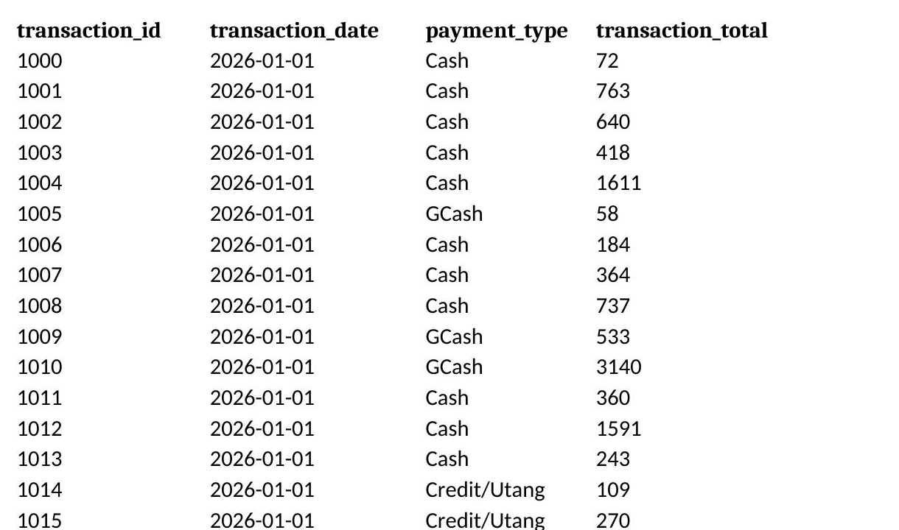
Figure — Preview of the first 20 rows of transactions.csv (cleaned dataset shown; the original pre-cleaning raw file was not retained, so this preview illustrates dataset structure rather than the raw-data issues described above)

Task 1.3 — Relational Database Design
The database was designed with four related tables: categories, products, transactions, and transaction_items. The transaction_items table serves as a bridge table connecting transactions to products, since one transaction can contain many products and one product can appear in many transactions. The products table links to categories via a foreign key.

Entity-Relationship Diagram
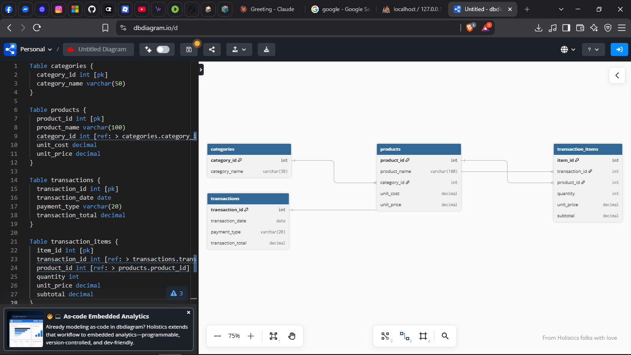
Figure — ERD generated via dbdiagram.io, showing categories, products, transactions, and transaction_items with primary/foreign key relationships

Populated Tables
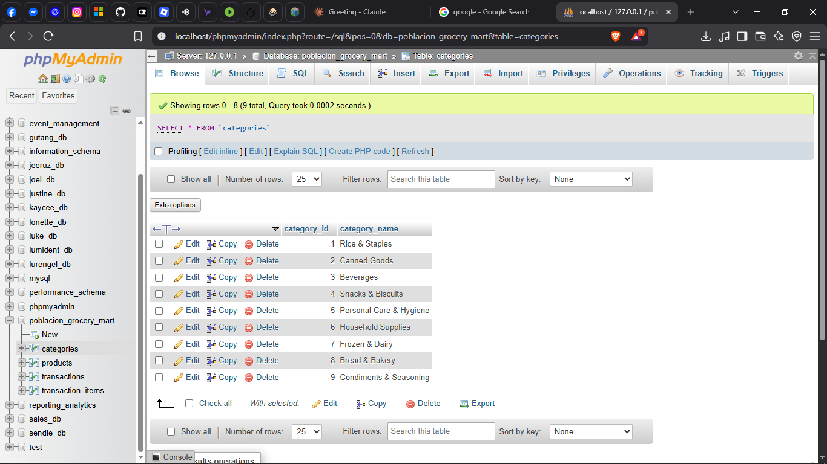
Figure — categories table populated (9 rows), phpMyAdmin
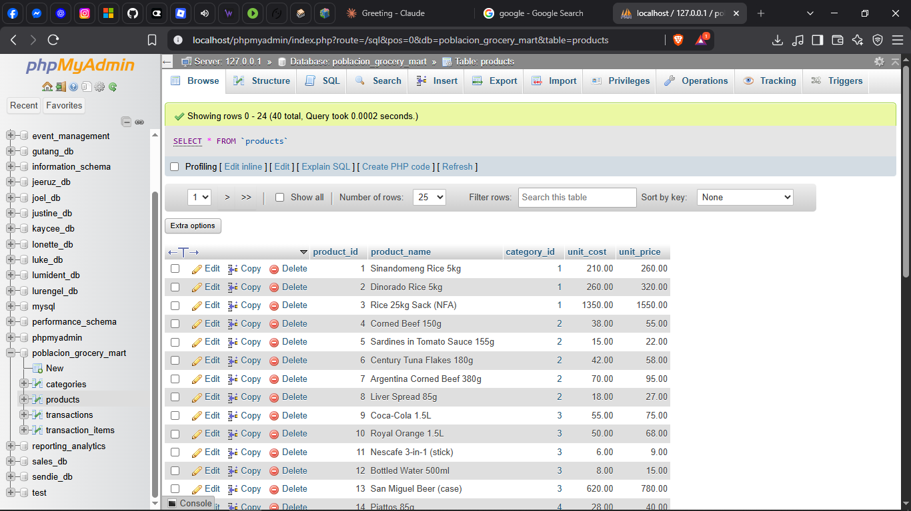
Figure — products table populated (40 rows), phpMyAdmin
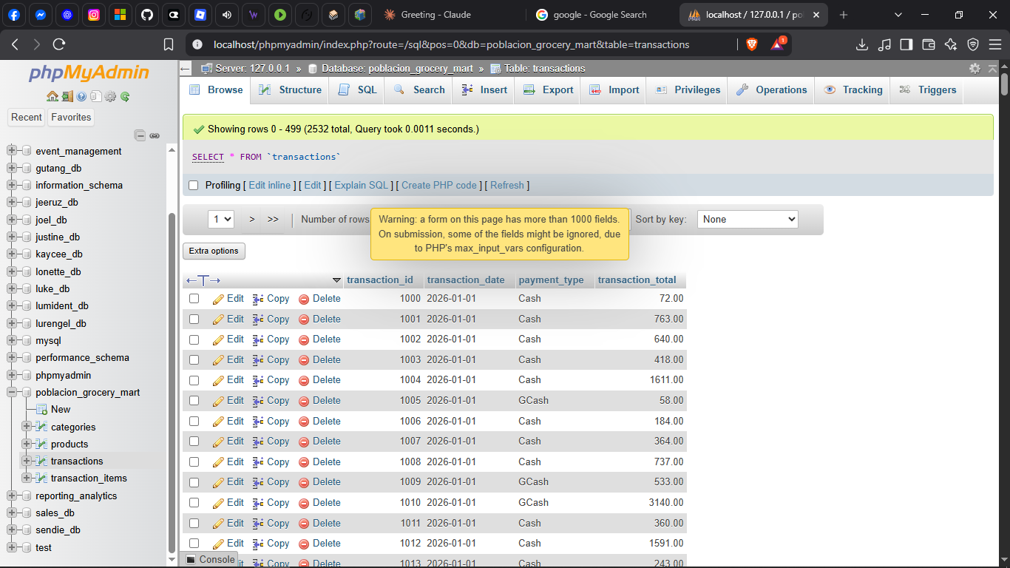
Figure — transactions table populated (2,532 rows), phpMyAdmin
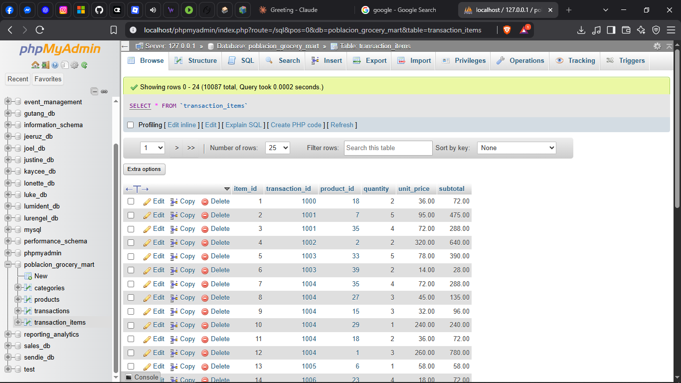
Figure — transaction_items table populated (10,087 rows), phpMyAdmin

Task 1.4 — SQL Query Report
Eight SQL queries were written and executed against the poblacion_grocery_mart database, covering SELECT with WHERE/ORDER BY, GROUP BY with aggregate functions, JOIN operations, and business-relevant queries answering the project's core research question.

Query 1 — SELECT with WHERE + ORDER BY
Business question: What are our beverage prices, highest to lowest?
SELECT product_name, unit_price
FROM products
WHERE category_id = 3
ORDER BY unit_price DESC;

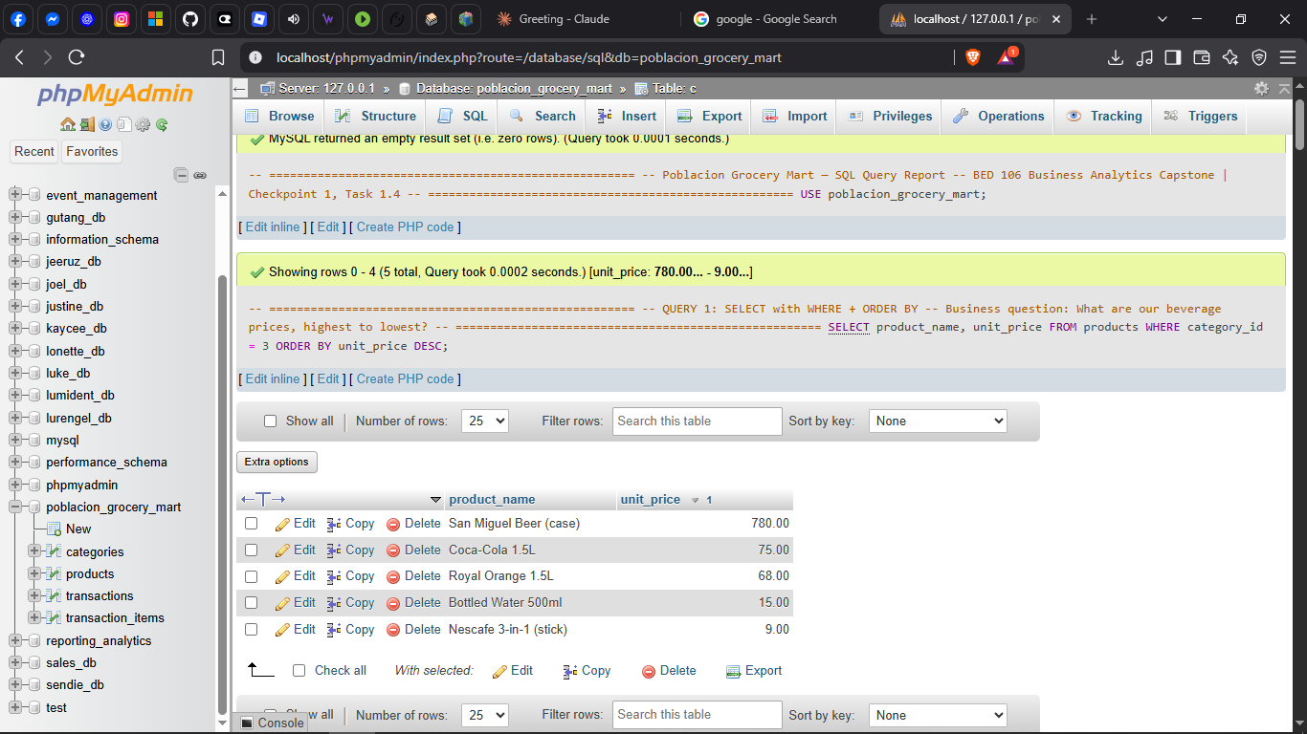
Figure — Query 1 result, phpMyAdmin
San Miguel Beer (case) is by far the priciest beverage at ₱780, more than 10 times the price of the next item, Coca-Cola 1.5L at ₱75, while Nescafe 3-in-1 sachets sell for as little as ₱9. This shows the beverage category spans a very wide price range, from a bulk adult beverage down to a single-serve daily staple, so pricing and promotion strategy for this category needs to account for very different customer needs and budgets.

Query 2 — SELECT with WHERE + ORDER BY
Business question: What are our largest GCash transactions?
SELECT transaction_id, transaction_date, transaction_total
FROM transactions
WHERE payment_type = 'GCash' AND transaction_total > 500
ORDER BY transaction_total DESC;

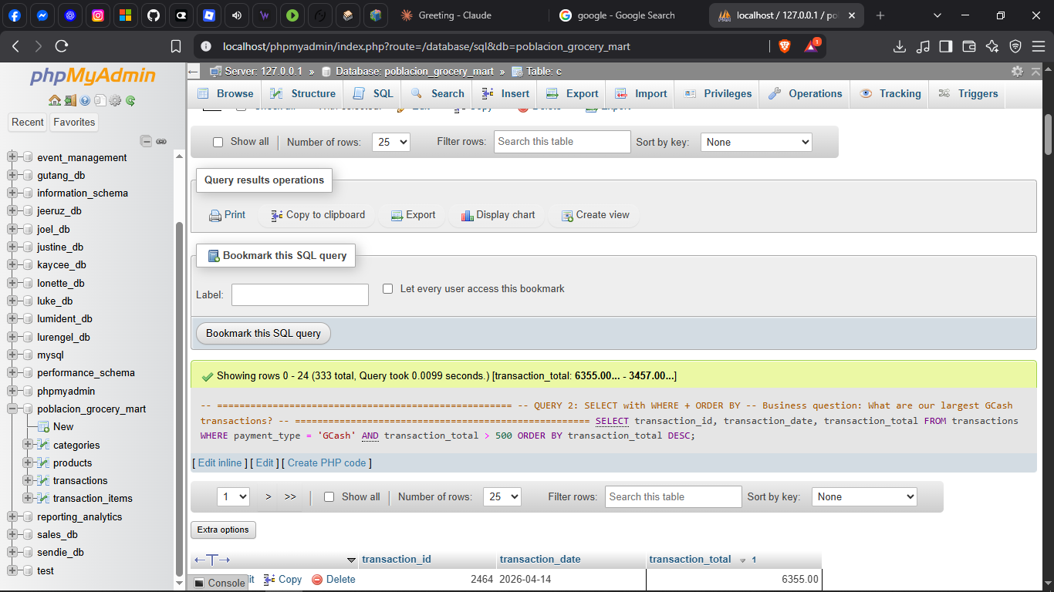
Figure — Query 2 result, phpMyAdmin
333 GCash transactions exceeded ₱500, with the single largest reaching ₱6,355 on April 14, 2026. This shows GCash is not just used for small convenience purchases — customers are comfortable using it for sizable grocery runs as well, which is useful to know if the store wants to further encourage cashless payments.

Query 3 — GROUP BY with aggregate functions
Business question: How much revenue comes from each payment method?
SELECT payment_type,
COUNT(*) AS num_transactions,
SUM(transaction_total) AS total_revenue,
AVG(transaction_total) AS avg_transaction_value
FROM transactions
GROUP BY payment_type
ORDER BY total_revenue DESC;

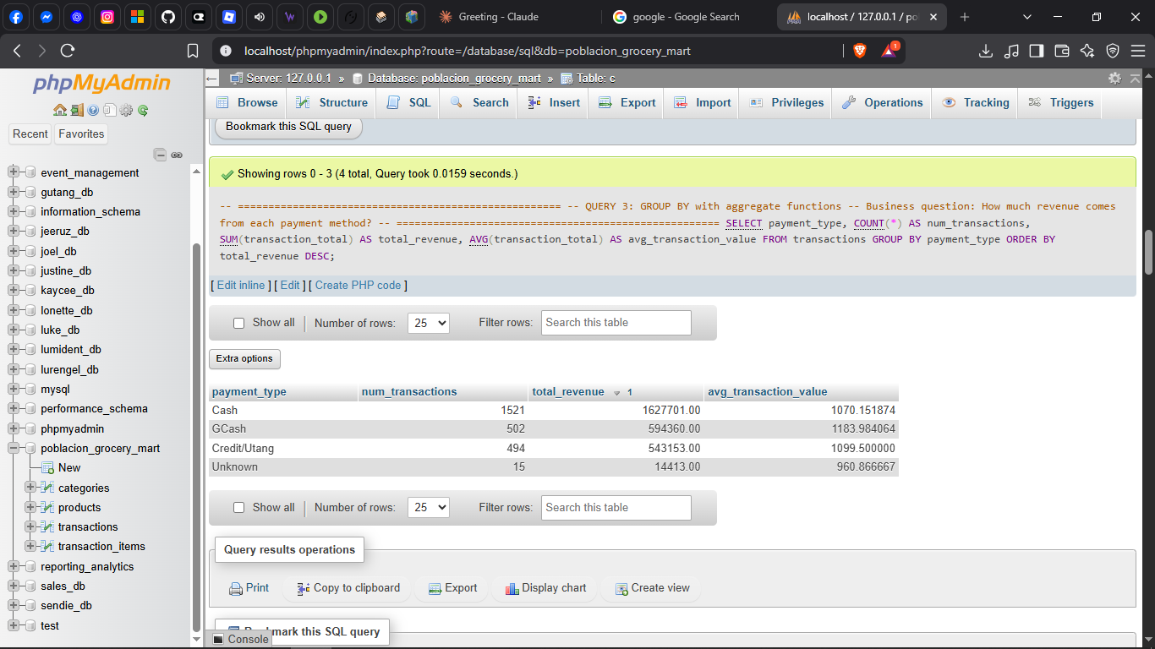
Figure — Query 3 result, phpMyAdmin
Cash remains the dominant payment method by volume, with 1,521 transactions generating ₱1,627,701 in revenue — more than the other three methods combined. However, GCash has the highest average transaction value at ₱1,183.98, followed closely by Credit/Utang at ₱1,099.50, suggesting that customers who pay digitally or on credit tend to buy more per visit than cash customers, who may be making smaller, more frequent purchases.

Query 4 — GROUP BY with aggregate functions
Business question: How does revenue trend month over month?
SELECT DATE_FORMAT(transaction_date, '%Y-%m') AS sales_month,
COUNT(*) AS num_transactions,
SUM(transaction_total) AS monthly_revenue
FROM transactions
GROUP BY sales_month
ORDER BY sales_month;

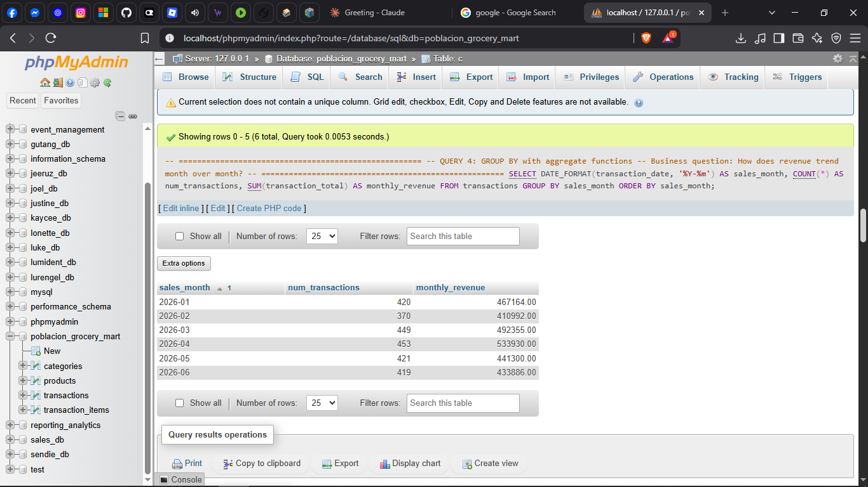
Figure — Query 4 result, phpMyAdmin
Monthly revenue stayed fairly stable across the 6-month period, ranging from a low of ₱410,992 in February to a high of ₱533,930 in April. April stood out as the strongest month in both transaction count (453) and revenue, which could be worth investigating further, but overall the store shows consistent rather than sharply fluctuating month-to-month sales.

Query 5 — JOIN
Business question: What products do we carry, organized by category?
SELECT p.product_name, c.category_name, p.unit_price
FROM products p
JOIN categories c ON p.category_id = c.category_id
ORDER BY c.category_name, p.product_name;

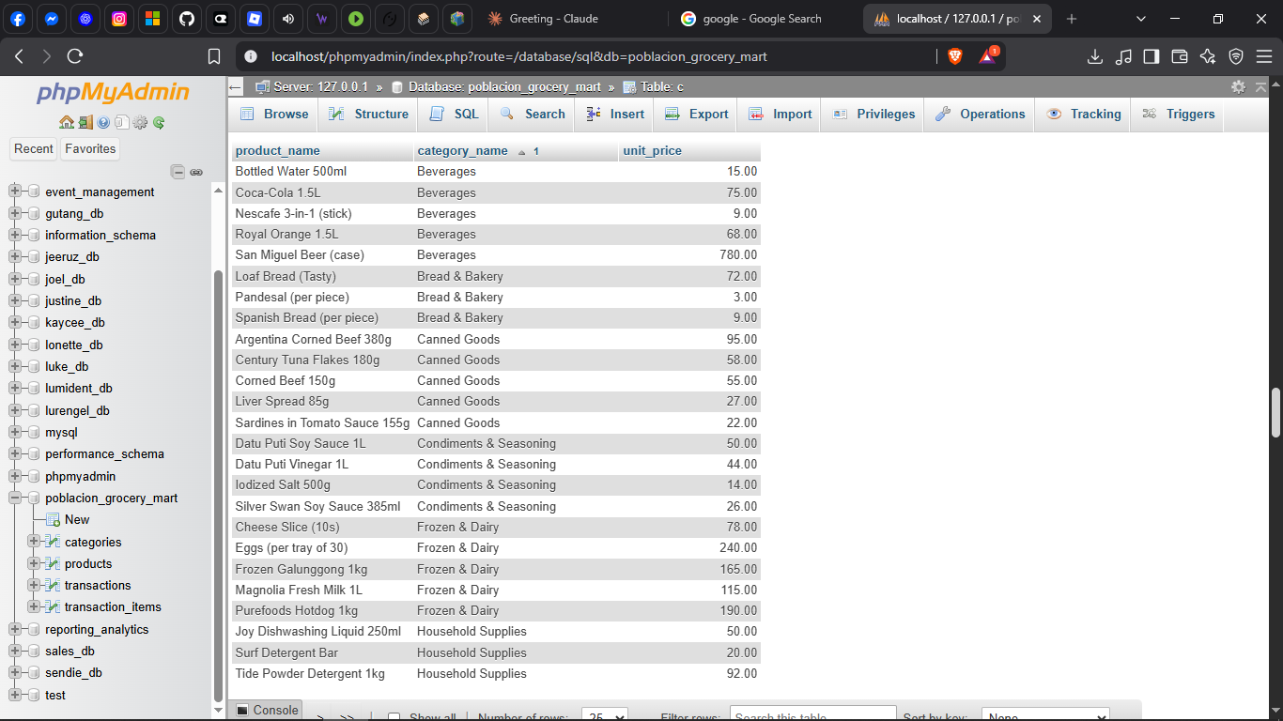
Figure — Query 5 result, phpMyAdmin
This query confirms that every product in the catalog is correctly linked to a category, from Beverages to Bread & Bakery to Canned Goods and beyond. Having this relationship in place is what makes it possible to reliably group and compare products by category later on, which is the foundation for answering the deeper business questions in Queries 7 and 8.

Query 6 — JOIN
Business question: What products were sold in each transaction?
SELECT ti.transaction_id, p.product_name, ti.quantity, ti.subtotal
FROM transaction_items ti
JOIN products p ON ti.product_id = p.product_id
ORDER BY ti.transaction_id
LIMIT 50;

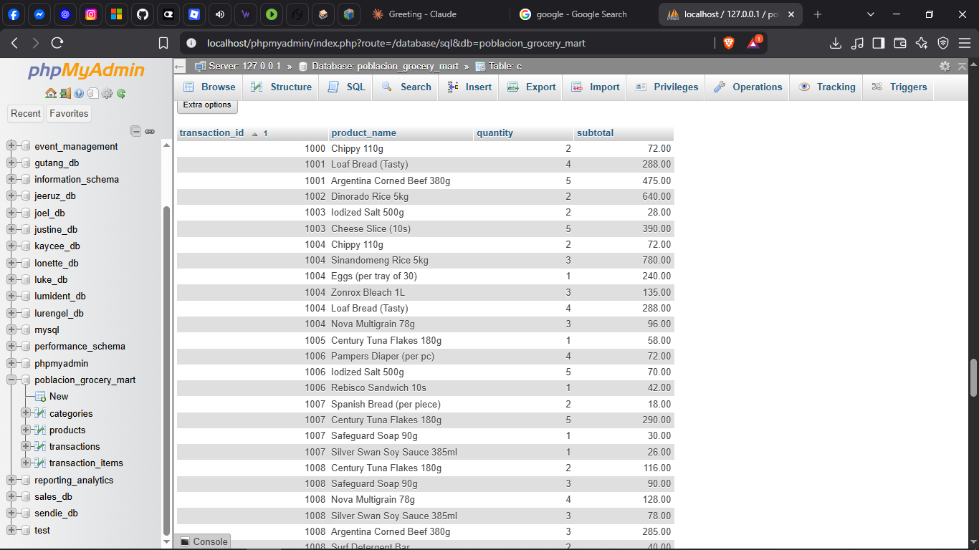
Figure — Query 6 result, phpMyAdmin
This query gives a transaction-level view of what customers actually buy together — for example, transaction 1004 included rice, eggs, bleach, bread, and multigrain crackers all in one visit. Seeing several line items under the same transaction_id confirms that customers commonly do multi-category grocery runs rather than single-item purchases, which points to opportunities like bundling items that are frequently bought together.

Query 7 — Business-relevant query (core research question)
Business question: Which product category drives the most revenue?
SELECT c.category_name,
SUM(ti.subtotal) AS total_revenue,
COUNT(DISTINCT ti.transaction_id) AS num_transactions
FROM transaction_items ti
JOIN products p ON ti.product_id = p.product_id
JOIN categories c ON p.category_id = c.category_id
GROUP BY c.category_name
ORDER BY total_revenue DESC;

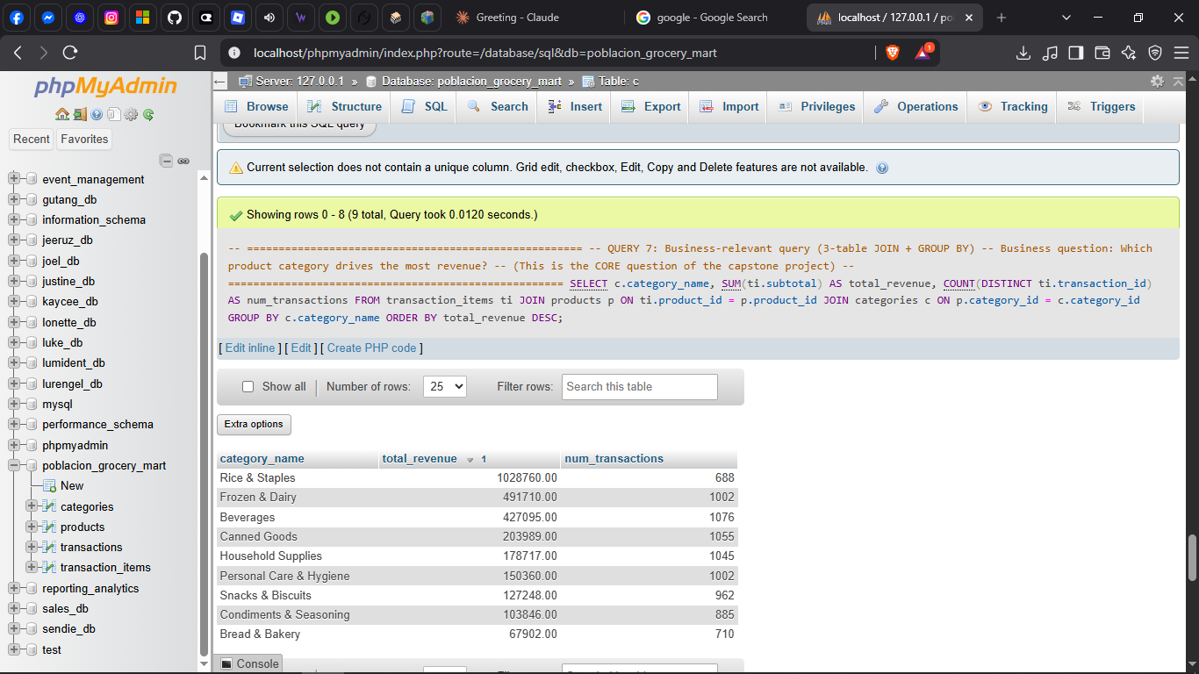
Figure — Query 7 result, phpMyAdmin
Rice & Staples generates the most revenue of any category at ₱1,028,760, well ahead of Frozen & Dairy (₱491,710) and Beverages (₱427,095), which directly answers the project’s core business question. Interestingly, Rice & Staples has fewer transactions (688) than Frozen & Dairy (1,076) or Beverages (1,002), which suggests its revenue lead comes from higher-value purchases like sacks of rice rather than sheer purchase frequency.

Query 8 — Business-relevant query
Business question: What are the top 10 individual products by revenue?
SELECT p.product_name, c.category_name,
SUM(ti.quantity) AS units_sold,
SUM(ti.subtotal) AS total_revenue
FROM transaction_items ti
JOIN products p ON ti.product_id = p.product_id
JOIN categories c ON p.category_id = c.category_id
GROUP BY p.product_name, c.category_name
ORDER BY total_revenue DESC
LIMIT 10;

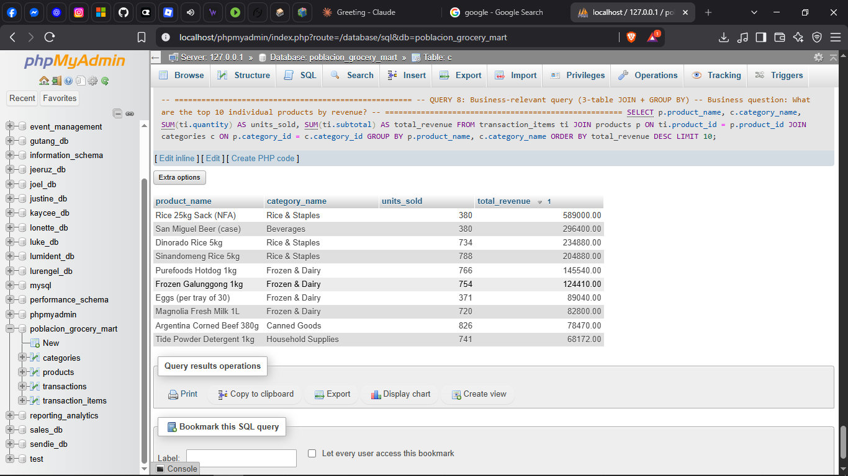
Figure — Query 8 result, phpMyAdmin
Rice 25kg Sack (NFA) is the single highest-revenue product at ₱589,000, followed by San Miguel Beer (case) at ₱296,400, even though both sold the exact same number of units (380) — showing how much unit price alone can separate two products’ revenue contribution. Five of the ten top products belong to either Rice & Staples or Frozen & Dairy, which reinforces the category-level findings from Query 7 and helps the owner prioritize which specific items to always keep well-stocked.

